GSS1 - Can you answer these queries I & GSS3 - Can you answer these queries III:
Problem: You are given a sequence A[1], A[2],...,A[N]. (|A[i]|≤15007, 1≤N≤50000).
A query is defined as follows:
Query(x,y) = Max { a[i]+a[i+1]+...+a[j] ; x ≤ i ≤ j ≤ y }.
Given M queries, your program must output the results of these queries.

Solution: Lets analyze this query.
Query(x, y) is the maximum of below values where sum(i, j) = a[i]+a[i+1]+......+a[j].

Left Sum: Where the range starts at 'x' but ends at anywhere in [x, y].
Right Sum: Where the range starts at somewhere in [x, y] and ends at 'y'.
Sum: Simply sum of all elements in interval [x, y].
Best Sum: Maximum possible sum in range [x, y].

Lets maintain 4 values.
bestLeftSum - Best of all the Left Sums, bestRightSum - Best of all the Right Sums
Sum - Sum of all the elements, bestSum - need to store resultSum of each query.
Logically, Query(x, y).resultSum = max (bestLeftSum, bestRightSum, sum, Query(x+1,y-1).bestSum);

Lets call the above info {bestLeftSum, bestRightSum, Sum,bestSum} as QueryNode. and given information about QueryNode(L, M) and QueryNode(M+1, R).
QueryNode(L, M) -> l and QueryNode(M+1, R) -> r. Then For QueryNode(L, R),

bestLeftSum = max (l.bestLeftSum, l.Sum + r.bestLeftSum);
bestRightSum = max (l.bestRightSum + r.Sum, r.bestRightSum);
Sum = l.Sum + r.Sum;
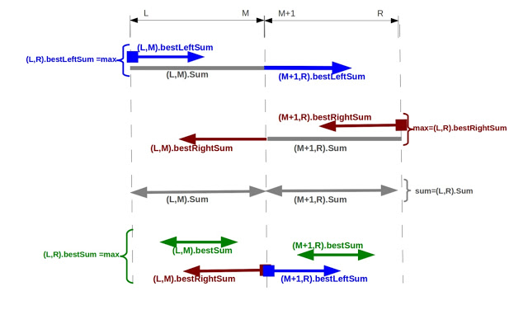
bestSum = max(l.bestSum, r.bestSum, l.bestRightSum + r.bestLeftSum)

